Diamond Problem in Python:
What is Diamond Problem?
Diamond Problem is problem related to ambiguity that occurs on multilevel inheritance. Let us suppose a Child class named Child has two Parent Class as Parent1 and Parent2. Both Parent1 and Parent2 also inherit from another class GrandParent. If Child wants to call a function from Grandparent, then ambiguity occurs as Program would not know which path to choose.

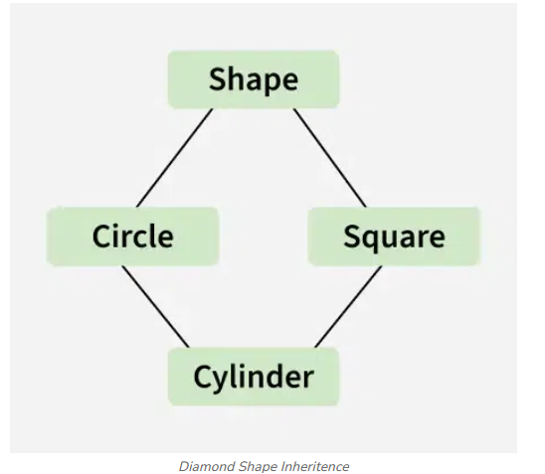

How is the Diamond Problem handled in Python?
In programming language like C++, Diamond Problem throws an exception which can be fixed by use of Virtual Functions. In Python however, Diamond Problem is automatically resolved with minimum User interference thanks to Method Resolution Order(MRO).
MRO is computed using a C3 Linearization Algorithm, which respects the order of inheritance while avoiding duplication.
Process of C3 Linearization Algorithm:
C3 Linearization computes the Method Resolution Order (MRO) of a class using a consistent rule that preserves the order of inheritance and avoids conflicts.
L(C) = [C] + merge(L(P1), L(P2), ..., L(Pn), [P1, P2, ..., Pn])
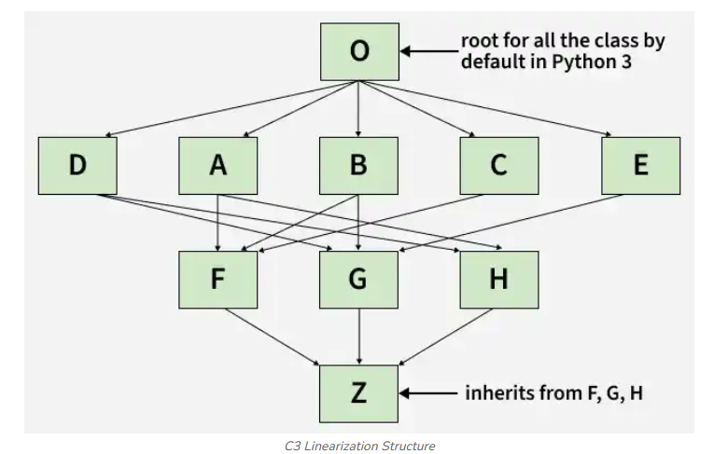
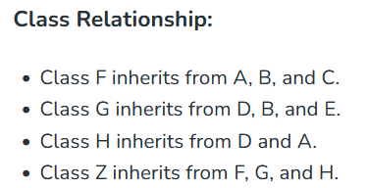
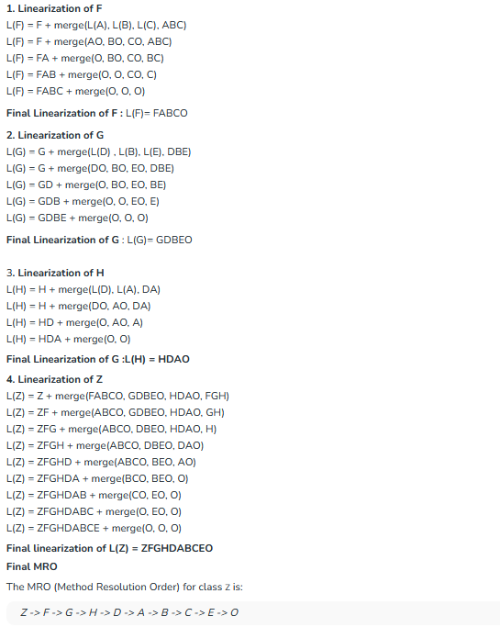

How to check the Order of MRO?
To check the Order of MRO we use:
Class_Name.mro()
Example Program with MRO:
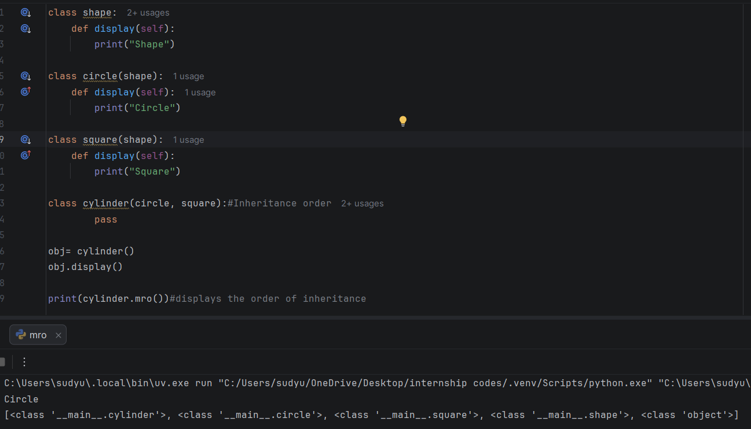
Here Circle is displayed as the Class Circle falls first on the inheritance list.

What to use if we want to show a function of Parent Class from Child Class?
This can be done using Super() before the function required to be called.
